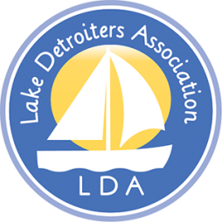  Mission: “To Promote the Protection and Enhancement of Detroit Lake.” | Lake Detroiters Association  Board of Directors  Meeting Notes  November 9, 2020  Zoom Virtual Meeting
Present: Laurie Olson, Dick Hecock, Brian Korbel, Brad Wimmer, John Cox, Linda Wiedemann, Carl Oberholtzer, Jamie Skarie, Carol Lee, Julie Herman, John Flynn, Aaron Tait
Absent: Barb Halbakken Fischburg, Jill Guerrino, Rochella Larson

Call to Order
- The meeting was called to order by President Brad Wimmer
- Quorum established.

Treasurer’s Report
- $4,235 for Website Update
- $118.00 Post Office Box Renewal

Secretary’s Report
- October report approved as read

BOD Holiday Party 2020

- No LDA Holiday Party will be held due to Covid 19 lockdown
- May consider a Spring picnic depending on where we're at with Covid

COLA
- Motion passed to continue COLA membership
- LDA Representation at COLA was discussed

Beach Captains
- Chairperson needed- Julie, Brad\Deb have expressed interest.
- There are a few open BC positions also
- Linda mentioned that planning should start in March at the latest.

2021 Annual Meeting
- Will discuss status of Covid 19 lockdowns at the Feb\March 2021 meetings
- Discussed possibility of delaying meeting until fall if necessary. Bylaws indicate the annual meeting is to happen in June.
- Invoicing for dues was mentioned as an option to consider. At this time no need to increase dues from $25.00
- Need worthwhile project going forward. Discussed a handicap sidewalk to the lake.

Committees\Officers for 2021-22
- Brad suggested that all directors take on one more task, beyond being a board member.

Meeting adjourned at 5:05

Respectfully submitted,

Laurie Olson, Secretary

Next Meeting: December , 4:00 PM Zoom meeting

