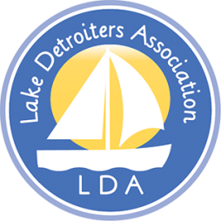  Mission: “To Promote the Protection and Enhancement of Detroit Lake.” | Lake Detroiters Association  Board of Directors  Meeting Notes  Following the 2021 Annual Meeting  South Shore Park
Present: Laurie Olson, Dick Hecock, Brian Korbel, Brad Wimmer, John Cox, Carol Lee, Carl Oberholzer, Julie Herman, Patty Mollberg

Absent: John Flynn, Rochella Larson, Kate Busker, Aaron Tait

Call to Order
- The meeting was called to order by President Brad Wimmer
- Quorum established.

Thank you to all Board Members for assisting with a highly successful annual meeting.

A brief meeting was held to elect officers, as per LDA Bylaws.

Election of Officers for 2021-2022- Motion Passed

President – Laurie Olson
Vice President – Jaime Skarie
Secretary – Dick Hecock
Treasurer – John Flynn

Respectfully submitted,

Laurie Olson, Secretary

Next Meeting – July 12, 2021 Location to be determined.

