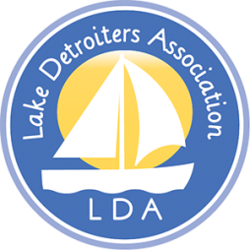  Mission: “To Promote the Protection and Enhancement of Detroit Lake.” | Lake Detroiters Association  Board of Directors  Meeting Notes  January 11, 2021  Zoom Virtual Meeting
Present: Laurie Olson, Dick Hecock, Brian Korbel, Brad Wimmer, John Cox, Carol Lee, Julie Herman, John Flynn, Aaron Tait Jill Guerrino, Carl Oberholzer, Jaime Skarie
Guest: Wanda Roden – COLA

Absent: Barb Halbakken Fischburg, Aaron Tait, Linda Wiedemann

Call to Order
- The meeting was called to order by President Brad Wimmer at 4:07 PM
- Quorum established.

Treasurer’s Report
- No Report available this month

Secretary Report
- Meeting notes from Nov 2020 and Dec 2020: Motion to approve – passed.

COLA Update – by guest Wanda Roden

- COLA – Is a cooperation of Lake Associations
- Education coordination with Lake Associations
- Dependent upon volunteer participation
- Request: Become engaged
- 2020 Newsletter will be shared with LDA BOD’s
- Schedule: May thru Oct Monthly meetings – Holiday Inn
- 3 Tier: Lake Association (LA) membership, Each LA representative, Officers elected by COLA representatives
- COLA is looking for more LA participation
- Jeff Forrester from MN Lakes and Rivers has been an active participant.
- Dick Hecock has been a long-term member and has been involved since its inception. (Was instrumental in the development)
- There are 25-30 lakes on the COLA roster
- Planning and Zoning representation – Goal
- COLA has been effective with involvement in County affairs.

DL 150 Sailboat Project

- Locations discussed: Highway 10 Overlook, Legion Beach, Pavilion, Across from The Bridge
- Committee will discuss further
- Photo needed for Social Media

Annual Meeting

- Locations discussed: Shorewood Pub, New South Shore Park
- Date: June 19, 2021

Meeting adjourned at 5:15 pm

Respectfully submitted,

Laurie Olson, Secretary

Next Meeting: February 8, 4:00 PM Zoom meeting

